**EE535: Control of Electrical Drive Systems**

**Assignment 1: DC Motor Drive**

**M. Shamaas**

**2018-MS-EE-4**

**DC Motor Model**

The DC Motor Dynamic Equations are

1. **Per unit Current and per unit Speed**



DC Model Transfer Function

If TL = 0,

is a 120 V step input applied at t = 0.1 s.

Substituting and TL = 0 in

Hence

Which represents a decaying sinusoid starting at t = 0.1s. Hence the simulation results are correct and thus a peak is seen in ia when ua is applied.

1. **Steady State per unit Current and per unit Speed**



Steady State Values

The calculations match with the simulation results.

1. **Limiting Rising Rate of Voltage**



Effect of Rate Limiter

is a 120 V / 0.1 s ramp at t = 0.1 s.

Hence,

Which represents the sum of a step function starting at t = 1 and an exponentially decaying sinusoid starting at t = 1. This matches with the simulation result.

Since,

Hence, is the sum of a ramp function starting at t = 0.1 s and an exponentially decaying cosine function. This matches with the simulation result.

**DC-DC Converter and Unipolar PWM**

1. **Testing the Model**

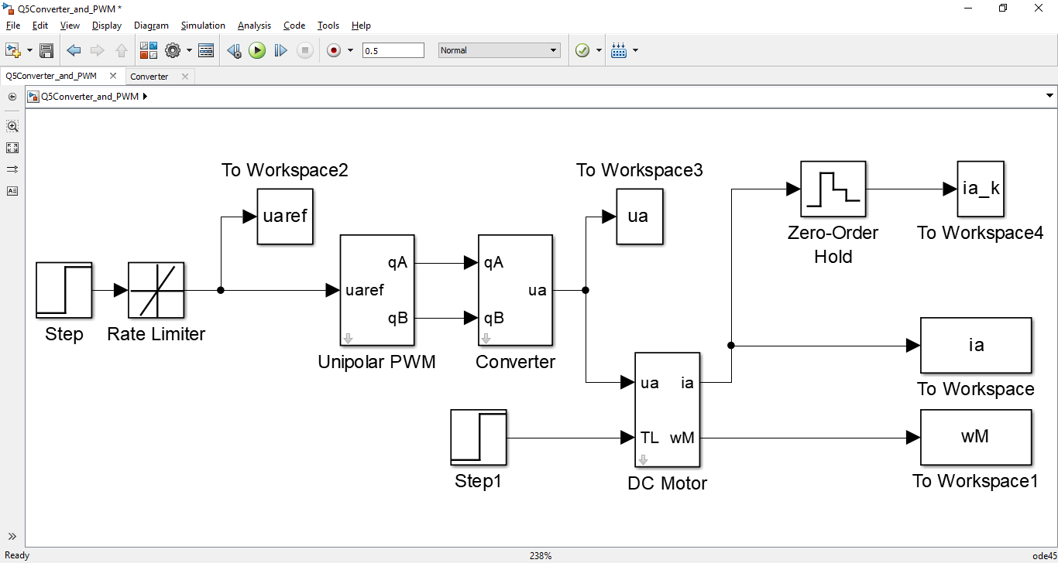



In this simulation, ua is supplied using PWM technique. The Average value of ua is equal to the reference ua. This is achieved by changing the duty cycles dA and dB. The results of current and speed are almost the same as the last section, where an ideal voltage source was used. The current has much more variation around the mean value as compared to the last case.

1. **Plotting Armature Voltage and Current**



The Armature current ia (blue) is a triangular wave because La charges up (current rises) when PWM output ua is high; and La discharges (current deceases) when PWM output becomes zero. The ua on/off sequence is such that the current rises and drops by equal amounts in steady state. Hence the sampled average current ia_k (red) seems constant.

**Cascaded Control**

1. **Current Control**

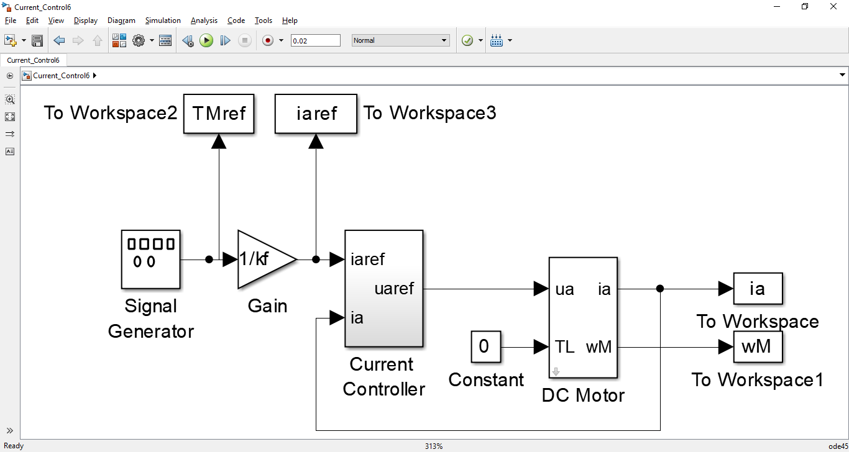





**Speed Control**

1. **Transfer Function**
2. **Testing the Model**



1. **Tolerances**



1. **Removing Anti-windup from Speed Controller**



